SEÇİCİ BİR SİTOTOKSİK AJAN OLARAK BROMELAİN: AKCİĞER HÜCRE MODELLERİNDE ÖN İN VİTRO DEĞERLENDİRME
Bromelain as a Selective Cytotoxic Agent: A Preliminary In Vitro Evaluation in Lung Cell Models
(TÜRKÇE VE İNGİLİZCE TAM METİNLERDE TÜRKÇE/İNGİLİZCE ÖZET VE BAŞLIK OLMALIDIR. türkçe ve ingilizce özet kısımlarının olması zorunludur – TAM METNİNİZİ TÜRKÇE YAZABİLİRSİNİZ. UNVAN VE UNİVERSİTE BİLGİLERİ İNGİLİZCE OLMALIDIR ! )

Assoc. Prof. Dr. Ferhunde AYSIN¹
¹Department of Biology, Faculty of Science, Ataturk University, Erzurum, TURKEY
ORCID ID: 0000-0003-1971-8031
f_aysin@yahoo.com

Assoc. Prof. Dr. Nihal Simsek OZEK¹
¹Department of Biology, Faculty of Science, Ataturk University, Erzurum, TURKEY
ORCID ID: 0000-0002-7326-5670
nsozek@yahoo.com

Assoc. Prof. Dr. Kubra KOC¹
¹Department of Biology, Faculty of Science, Ataturk University, Erzurum, TURKEY
ORCID ID: 0000-0001-6208-165X
kubrakc@hotmail.com
ÖZET
Bromelain, Ananas comosus (ananas) bitkisinden elde edilen proteolitik bir enzim olup geniş bir biyolojik aktivite yelpazesi göstermektedir. Düşük sistemik toksisitesi ve yüksek biyouyumluluğu, onu farmasötik uygulamalar açısından umut verici bir aday hâline getirmektedir. Son yıllarda yapılan çalışmalar, bromelainin antiinflamatuvar, immünomodülatör, antitrombotik ve antikanser özelliklere sahip olduğunu ortaya koymuş ve kanser tedavisinde kullanılma potansiyeline işaret etmiştir. Bu çalışmada, bromelainin seçici sitotoksik potansiyelinin değerlendirilmesi amacıyla, akciğer kanseri hücreleri (A549) ile normal bronşiyal epitel hücreleri (BEAS-2B) üzerindeki etkileri in vitro koşullarda karşılaştırılmış; böylece olası terapötik önemi ve güvenlilik profili araştırılmıştır.
Hücreler, 48 saat boyunca farklı bromelain konsantrasyonlarıyla (0, 9,76, 19,53, 39,06, 78,125, 156,25, 312,5 ve 625,0 µg/mL) muamele edilmiştir. Hücre canlılığı MTT testi ile değerlendirilirken, morfolojik değişiklikler kristal viyole boyaması ile incelenmiştir. Ayrıca apoptotik ve nekrotik hücre ölüm mekanizmaları akış sitometrisi yöntemi kullanılarak analiz edilmiştir. Elde edilen bulgular, bromelainin A549 hücreleri üzerinde doza bağlı sitotoksik etki gösterdiğini ortaya koymuştur. Özellikle yüksek dozlarda, A549 hücrelerinin BEAS-2B hücrelerine kıyasla daha düşük duyarlılık gösterdiği belirlenmiştir. Kristal viyole boyama sonuçları, hücre hasarına özgü karakteristik değişimleri ortaya koymuş; bu bulgular akış sitometrisi analizleriyle desteklenmiştir. Akış sitometrisi sonuçları, bromelainin doza bağlı olarak apoptozu güçlü bir şekilde indüklediğini ve bu etkinin ağırlıklı olarak erken apoptozdan geç apoptoza geçiş yoluyla gerçekleştiğini göstermiştir.
Sonuç olarak, bromelainin akciğer kanseri için seçici bir antikanser bileşik olabileceği ve yüksek dozlarda dahi oldukça düşük sitotoksisite göstermesi nedeniyle potansiyel bir terapötik ajan olarak değerlendirilebileceği düşünülmektedir.
Anahtar Kelimeler: A549, BEAS-2B, Bromelain, Kristal viyole, Akış sitometrisi.

ABSTRACT
Bromelain is a proteolytic enzyme derived from Ananas comosus that has shown a wide range of biological activities. Its low systemic toxicity and high biocompatibility make it a promising candidate for pharmaceutical applications. Recent studies have highlighted its anti-inflammatory, immunomodulatory, anti-thrombotic, and anticancer properties, suggesting its potential use in cancer treatment. This study aimed to assess the selective cytotoxic potential of bromelain by comparing its effects on lung cancer (A549) and normal bronchial epithelial (BEAS-2B) cells in vitro, to clarify its therapeutic relevance and safety profile as a candidate anticancer agent. Cells were treated with various concentrations of bromelain (0, 9.76, 19.53, 39.06, 78.125, 156.25, 312.5, and 625.0 µg/mL) for 48 hours. Cell viability was assessed using the MTT assay, while morphological alterations were examined by crystal violet staining. Moreover, apoptotic and necrotic cell death mechanisms were analysed using flow cytometry. Additionally, apoptosis/necrosis cell death processes were also examined using flow cytometry. Bromelain showed a dose-dependent cytotoxic effect on A549 cells, which were less sensitive than BEAS-2 B cells, especially at higher doses. Crystal violet staining showed characteristic cell damage patterns, which were further supported by flow cytometry, indicating a very high dose-dependent induction of apoptosis, primarily through a transition from early to late apoptosis. It may be concluded that bromelain could be a selective anticancer compound for lung cancer, which has very low cytotoxicity even at higher doses.
Keywords: A549, BEAS-2B, Bromelain, Crystal violet, Flow cytometry.

(TAM METİN KISMINI TÜRKÇE YAZABİLİRSİNİZ TÜRKÇE YAZIM OLABİLİR.)
INTRODUCTION

Bromelain, an enzyme mixture of proteolytic nature from the pineapple plant (Ananas comosus) core and fruit, has recently attracted significant interest for its wide therapeutic applications (Pavan et al., 2012). Many in vitro and in vivo studies have already demonstrated its potency across various biological processes and have proposed its therapeutic value in treating certain diseases (Chobotova et al., 2010). Recent studies have focused on its anti-inflammatory, immunomodulatory, anti-thrombotic, and anti-cancerous properties and have displayed its therapeutic potency in integrative oncology (Pavan et al., 2012; Bajoria et al., 2025). However, its non-toxicity and biocompatibility render it feasible for use in oral and parenteral forms (Maurer, 2001). Current evidence also shows its ability to interact with tumour growth and metastasis by modulating vital cellular processes such as apoptosis, cell cycle regulation, and cytokine expression (Sukumaran et al., 2020). Additionally, its viability upon entrapment in poly(vinyl alcohol)/hydroxyethyl cellulose (PVA/HEC) nanofibrous matrix has been validated, retaining its enzyme integrity and inducing conspicuous cytotoxic effects upon in vitro evaluation of its admissibility and legitimacy with advanced drug delivery systems and cancer therapies (Balakrishnan et al., 2025). Moreover, its feasibility has been validated for increasing drug absorption and reducing undesirable chemical reactions during chemotherapeutic treatment regimens, making it an invaluable adjunct in cancer therapy (Chobotova et al., 2010). Importantly, its selective cellular toxicity has been documented to cause negligible damage to healthy cells and inducecytotoxic effects on malignant cells. Presently, considerable interest has been generated regarding its applicability and potential for valorization as a relatively safe complement to conventional cancer chemotherapeutic agents (Martinez-Benavidez & Vergara-Pineda, 2025). Despite its well-established applicability and utility as a digestive enzyme, research into its various therapeutic mechanisms, including apoptosis induction, cell cycle arrest, and regulation of pro-inflammatory cytokines, has been intensively pursued in the context of solid tumours.
Owing to its promising properties, bromelain continues to appear on the radar as a multifunctional bioactive compound with significant implications for cancer treatment. This research focused on a research investigation into the influence of bromelain on cancer cell lines in vitro to better understand the therapeutic potential of the bioactive compound. To fulfill the research objectives of the investigation, the potential cytotoxicity of bromelain on lung cancer cells (A549) was assessed relative to its effects on normal human bronchial epithelial cells (BEAS-2B).

Material and Methods

Chemicals and Cell Cultures
A549 (human lung carcinoma) (Cat. No. CCL-185 ATCC®) and BEAS-2B (human bronchial epithelium) (Cat No. CRL-3588 ATCC®), cell lines were obtained from the Eastern Anatolia High Technology Research and Application Center (DAYTAM) (Atatürk University, Erzurum, Turkey). Bromelain was purchased from Orzax Ocean firm (TURKEY). All other chemicals used for the study werre obtained from Sigma-Aldrich, Inc. (St. Louis, MO, USA).

Cell Viability Assay (MTT)
A549 and BEAS-2B cells were cultured under standard conditions. A549 cells were maintained in high-glucose DMEM, and BEAS-2B cells in DMEM/F12 medium, both supplemented with 10% fetal bovine serum (FBS), 100 IU/mL penicillin, and 100 µg/mL streptomycin. The cells were incubated at 37 °C in a humidified atmosphere containing 5% CO₂. Each cell line was seeded in 96-well plates at a density of 1 × 10⁴ cells per well in 150 µL of medium and allowed to adhere for 24 hours. After incubation, cells were treated with bromelain at concentrations of 0, 9.76, 19.53, 39.06, 78.125, 156.25, 312.5, and 625.0 µg/mL for 48 hours. A 5% dimethyl sulfoxide (DMSO) solution was used as a positive control. Following the treatment period, cell viability was assessed using the MTT assay (3-(4,5-dimethylthiazol-2-yl)-2,5-diphenyltetrazolium bromide). 20 µL of MTT solution was added to each well, and the plate was incubated for 4 hours. Formazan crystals were dissolved by adding 150 µL of DMSO to each well. Absorbance was measured at 570 nm using a microplate reader. All experiments were performed in triplicate, and cell viability was expressed as a percentage relative to untreated control cells.

Morphological Assessment
Morphological alterations caused by bromelain treatment were assessed by crystal violet staining. Cells were treated with bromelain at various concentrations for 48 hours, after which they were carefully washed twice with PBS to remove the medium and to loosen non-adherent cells. Remaining adherent cells were fixed by adding cold methanol for 10 minutes. Cells were fixed and stained with 0.5% crystal violet for 15 minutes. Excess dye was removed by carefully rinsing the wells with distilled water, allowing the plates to air dry. Stained cells were visualised under an inverted light microscope (ZEISS AXIO SCOPE) at 100× magnification. Morphological features such as cell shrinkage, rounding, membrane blebbing, and detachment—indicative of cytotoxicity and cell death—were noted and compared between treated and control groups.

Annexin V-FITC and PI analysis
Quantitative determination of apoptotic and necrotic cell death caused by the effect of Bromelain in A549 and BEAS-2B cells was performed with Annexin V Apoptosis Detection Kit FITC following the manufacturer's protocol (FITC Annexin V Apoptosis Detection Kit with PI, BioLegend). After treatment, the cells were washed with PBS and 1X binding buffer by centrifugation at 1500 rpm. 1 × 10⁶ cells were resuspended in 1 ml of 1X binding buffer. 5 µl of fluorochrome-conjugated Annexin V was added to each 100 µl of cell suspension, and the mixture was incubated for 15 minutes. After all cells were rewashed, 200 µl were resuspended in the same buffer, and 5 µl propidium iodide (PI) was added. Stained cells were diluted with binding buffer and analyzed with the Beckman Coulter CytoFLEX Flow Cytometer in DAYTAM. Fluorescence distribution was displayed as a two-color dot plot analysis, and the percentage of fluorescent cells in each quadrant was measured.

Statistics
The statistical analysis was performed using GraphPad Prism version 6.0 (GraphPad Software, La Jolla, California, USA). The differences among groups were compared using one-way analysis of variance (ANOVA) followed by Tukey’s multiple-comparison test to assess statistical significance.

Results

Cytotoxic effect of Bromelain on A549 and BEAS-2B cells
MTT assay results demonstrated a dose-dependent decrease in cell viability following bromelain treatment in both A549 and BEAS-2B cell lines (Figure 1).
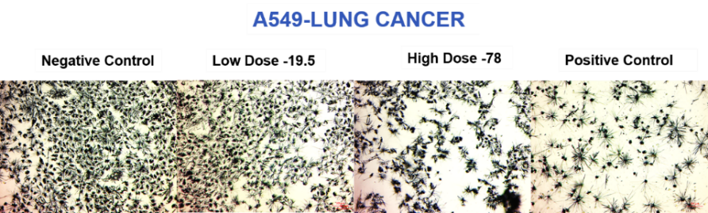
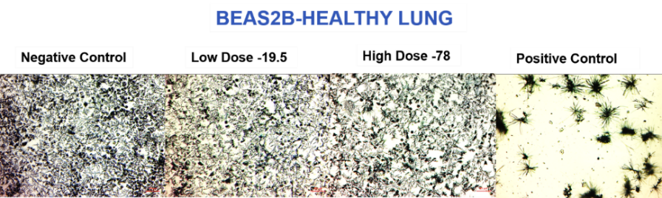
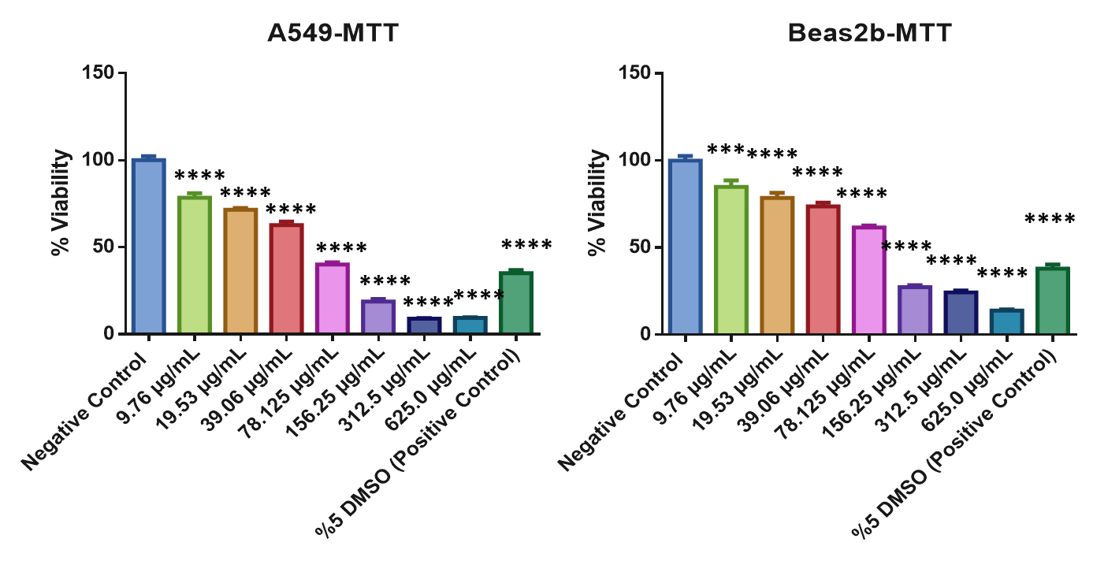
Figure 1. Representative microscopy images and MTT assay results of A549 and BEAS-2B treated with bromelain for 48 h. Scale bar = 50 µm. Data are expressed as percentage cell viability relative to the negative control. Error bars represent the standard error of the mean (SEM) from three independent experiments. Error bars correspond to the standard error of the mean of three repeated experiments. ** p < 0.01; *** p < 0.001; **** p < 0.0001 shows significant differences between the control and other studied groups.

In A549 cells, a significant reduction in viability was observed at concentrations ≥78.125 µg/mL, indicating a pronounced cytotoxic effect. Conversely, BEAS-2B cells exhibited minimal cytotoxicity at lower concentrations, with a notable decrease in viability only at 312.5 and 625.0 µg/mL.
Morphological evaluation using crystal violet staining (Figure 2) supported the MTT findings, showing dose-dependent structural alterations, including cell rounding, shrinkage, and detachment, particularly evident in A549 cells treated with higher bromelain concentrations. The concordant reduction in metabolic activity and clonogenic survival observed in A549 cells, but not in BEAS-2B cells, suggests that bromelain selectively targets lung cancer cells, possibly through differential regulation of mitochondrial function and cell adhesion mechanisms.

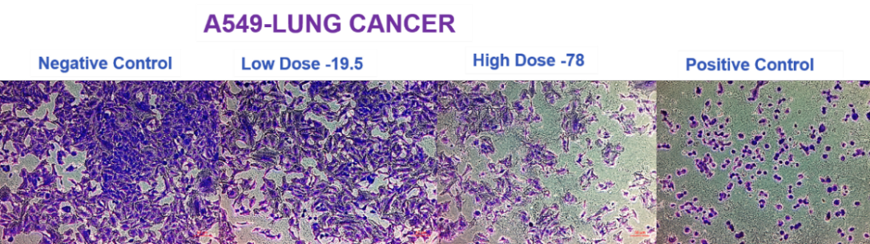
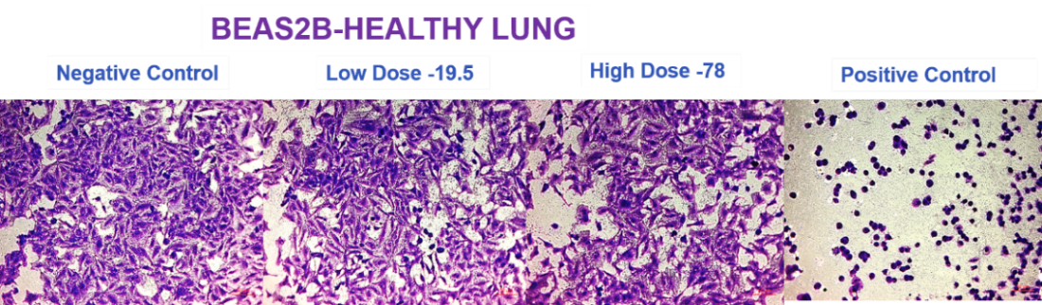
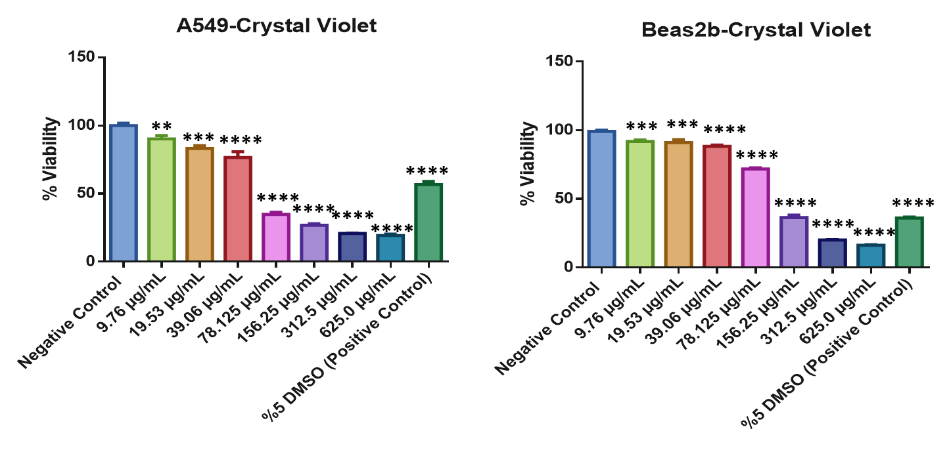
Figure 2. Morphological alterations and cell viability of A549 and BEAS-2B cells following bromelain treatment for 48 h (stained with crystal violet). Scale bar = 50 µm. Quantitative analysis of cell viability was performed using the crystal violet assay after 48 h of treatment with increasing concentrations of bromelain. Data are expressed as percentage cell viability relative to the negative control. Error bars correspond to the standard error of the mean of three repeated experiments. ** p < 0.01; *** p < 0.001; **** p < 0.0001 shows significant differences between the control and other studied groups.

Determination of Bromelain-induced death types in A549 and BEAS-2B cells
Flow cytometric charts of A549 and BEAS-2B cells exposed to 5% DMSO (positive control), 9.5 and 78.125 µg/mL Bromelain for 48 hours (Figures 3). In A549 cells, bromelain treatment induced a pronounced, dose-dependent apoptotic response, characterised by a progressive shift from early to late apoptotic stages rather than necrosis. The proportion of apoptotic cells increased substantially at higher bromelain concentrations, confirming activation of programmed cell death pathways. In contrast, BEAS-2B cells showed relative resistance to bromelain-induced apoptosis, particularly at lower concentrations, with only a modest increase in apoptotic fraction at the highest dose. These results collectively demonstrate that bromelain selectively triggers apoptosis in lung cancer cells while exerting minimal cytotoxic effects on normal bronchial epithelial cells.
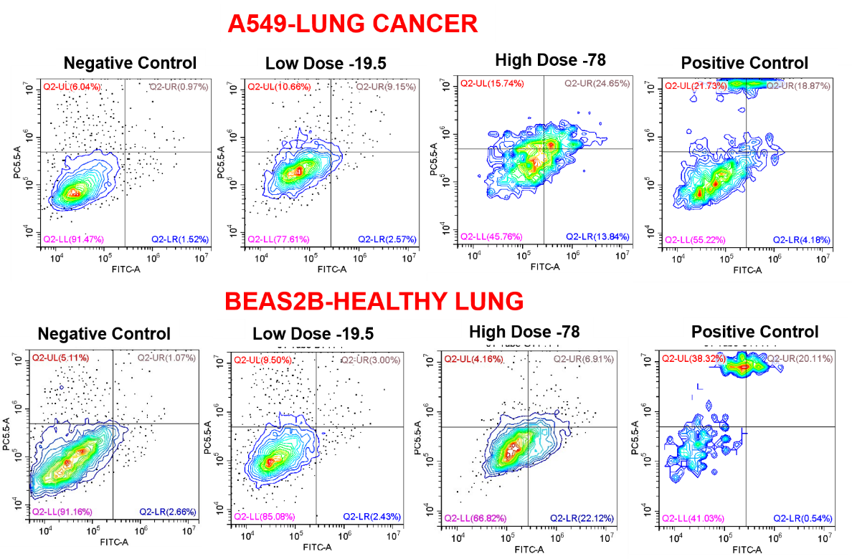
Figure 3. Flow cytometric analysis was performed to detect the proliferation of A549 and BEAS-2B following treatment with Bromelain for 48 h. A549 cancer cells: Rapid, dose-dependent induction of early and late apoptosis. Strong shift from live to apoptotic quadrants. BEAS-2B normal cells: Mild apoptosis, mainly at high dose. The majority of cells remain viable at therapeutic concentrations.
DISCUSSION

The current study demonstrates that bromelain exhibits selective toxicity against human lung adenocarcinoma cells (A549) but not against normal bronchial epithelial cells (BEAS-2B). This result confirms previous confirmatory findings demonstrating bromelain’s preference in treating cancer over normal cells (Chobotova et al., 2010; Bhui et al., 2009) and further confirms in several current studies showing that bromelain causes the generation of oxidative stress and mitochondrial damage in cancer cells of the lungs (Hossain et al., 2023; Bhatnagar et al., 2022).
Based on the flow cytometry analysis in this study, there is mechanistic proof of bromelain's pro-apoptotic rather than pro-necrotic activity against A549 cells, as indicated by a concentration-dependent increase in both early and late apoptotic events. The predominance of apoptosis suggests that bromelain exerts its pro-apoptotic action through programmed cell death rather than unprogrammed and ubiquitous membrane damage. Such pro-apoptotic activity of bromelain has already been confirmed in other cancer models, where it induced an intrinsic form of apoptosis characterized by mitochondrial depolarization, cytochrome c release, and activation of caspase-9 and caspase-3 (Raján et al., 2022; Tsai et al., 2023). The low level of necrosis further reinforces the notion that bromelain's pro-apoptotic activity is concentration-specific and specialized. More importantly, its poor ability to induce apoptosis in BEAS-2B cells at equal concentrations suggests a marked preference for target-cell selectivity, which could be related to differences in cellular redox balance and metabolism between cancer and healthy cells.
Results from the MTT assay also confirmed a dose-dependent decrease in viability of A549 cells, confirming previous research on the inhibitory effects of bromelain on the proliferation of different cancer cell lines, such as breast cancer, colon cancer, and gastric cancer cells (Beccatini et al., 2021; Dhandayuthapani et al., 2011). The relative viability of BEAS-2B cells also reflects their relative resistance and potentially favorable therapeutic index. This has been described in prior literature citing minimal systemic toxicity and excellent biocompatibility (Maurer, 2001). A549 cells showed also significant alterations in cellular morphology associated to apoptotic/necrotic cell death (shrinkage, loss of adherence and rounding) by crystal violet staining. Similarly, cytopathic effects resulting from the treatment of PANOC1 cells with bromelain have been reported on other studies investigating its pro-apoptotic effect in pancreatic and colorectal carcinoma (Chakraborty et al., 2010). Morphological examination and crystal violet staining coincide with the results of MTT assay. The typical morphological characteristics were presented in bromelain-treated A549 cells such as smaller size, rounding change, membrane bubbling and cell detachment with concentration increase. These morphological alterations agreed with other reports that demonstrated apoptosis induced by bromelain in carcinoma models, based on cytoplasmic condensation loss of membrane integrity and the subsequent the fragmentation of cells (Bhui et al., 2009; Chobotova et al., 2010). In contrast, the BEAS-2B cells preserved their epithelial characteristics and only slight changes were evident when very high bromelain concentrations were used. This morphological integrity corroborates other reports (Maurer, 2001) that the compound is selective for tumour tissues maybe because of broad differences in cell and redox metabolism. Because it has certain pharmacological properties, such as being more accessible orally, biocompatibility being relatively good and developments in the application of new drugs and so on, bromelain becomes a potential adjuvant for integrative therapies against cancer (Maurer, 2001; Singh et al., 2022). Its non-cytotoxic effect in BEAS-2B cells as well as on cell cycle distribution also verifies its selectivity, making it a potential drug adjuvant for cancer.
In light of the conclusions drawn from this experiment and other recent studies in the literature, bromelain was found to exhibit vigorous cytotoxicity that is both concentration- and time-dependent in A549 lung cancer cells. However, it remains non-toxic to normal BEAS-2B cells. The cytotoxic effect of bromelain on cancer cells was manifested by inducing morphological changes, decreasing cell viability, and inhibiting cell cycle progression. Hence, bromelain remains a promising selective anticancer drug. However, further studies are needed to determine its function and role in cancer treatment.

REFERENCES

Bajoria, A. A., Parida, N., Kokkanti, R. R., et al. (2025). Innovative anti-fibrotic strategy using a bromelain-containing mucoadhesive patch for effective collagen breakdown and cytotoxicity in oral submucous fibrosis. Materials Today: Proceedings.
Balakrishnan, S. B., Ibrahim, L., Shanmugasundaram, E., et al. (2025). Bromelain-Infused Poly(vinyl alcohol)/Hydroxyethyl Cellulose Nanofibrous Scaffolds for Cancer Therapy: Fabrication, Characterization, and In Vitro Assessment. ACS Omega
Beccatini, C., et al. (2021). Effects of bromelain on cancer stem cell populations in vitro. Journal of Ethnopharmacology, 266, 113421.
Bhatnagar, A., Chandel, M., & Sharma, A. (2022). Anti-cancer activity of bromelain in non-small cell lung cancer via apoptosis and proliferation inhibition. Journal of Ethnopharmacology, 295, 115327.
Bhui, K., Prasad, S., George, J., et al. (2009). Bromelain inhibits COX-2 expression and induces apoptosis in mouse skin papillomas. Cancer Letters, 282(2), 167–176.
Chakraborty, P., Dutta, A., & Banerji, A. (2010). Bromelain-induced apoptosis in colorectal cancer cells via mitochondrial pathway. Molecular and Cellular Biochemistry, 342, 91–99.
Chobotova, K., Vernallis, A. B., & Majid, F. A. A. (2010). Bromelain’s activity and potential as an anti-cancer agent: Current evidence and perspectives. Cancer Letters, 290(2), 148–156.
Dhandayuthapani, S., et al. (2011). Bromelain-induced apoptosis in breast cancer cells via ROS-mediated mitochondrial pathway. Biotechnology Letters, 33(6), 1321–1328.
Hossain, M., Rahman, M. M., & Sultana, T. (2023). Bromelain-induced oxidative stress and mitochondrial dysfunction in A549 lung carcinoma cells. Phytomedicine, 121, 154982.
Martínez-Benavidez, E., & Vergara-Pineda, A. M. (2025). Effect of Totoaba macdonaldi Swim Bladder Collagen Hydrolysates on Breast Cancer Cells and Human Dermal Fibroblasts. Preprints.org.
Maurer, H. R. (2001). Bromelain: biochemistry, pharmacology and medical use. Cellular and Molecular Life Sciences, 58(9), 1234–1245.
Pavan, R., Jain, S., Shraddha, & Kumar, A. (2012). Properties and therapeutic application of bromelain: a review. Biotechnology Research International, 2012, 976203.
Rajan, P. K., Dunna, N. R., & Venkatabalasubramanian, S. (2022). A comprehensive overview on the anti-inflammatory, antitumor, and ferroptosis functions of bromelain: An emerging cysteine protease. Expert Opinion on Biological Therapy, 22(5), 615-625.
Singh, R., Sharma, M., & Gupta, M. (2022). Bromelain as an oral adjunct in cancer therapy: Clinical and mechanistic perspectives. Nutrients, 14(9), 1930.
Sukumaran, N. P., et al. (2020). Bromelain inhibits the proliferation of colorectal cancer cells by inducing cell cycle arrest and apoptosis. Scientific Reports, 10, 21255.
Tsai, K. Y., Wei, P. L., Azarkan, M., M’Rabet, N., Makondi, P. T., Chen, H. A., ... & Chang, Y. J. (2023). Cytotoxic properties of unfractionated and fractionated bromelain alone or in combination with chemotherapeutic agents in colorectal cancer cells. PLoS One, 18(6), e0285970.

